**Experiment 2.4**

**Decision Trees and Random Forests**

|  |  |
| --- | --- |
| **Student Name: Ishu Rattan** | **UID: 20BCS7755** |
| **Branch: CSE** | **Section/Group: 806-B** |
| **Semester: 5th Semester** |  |
| **Subject Name: Machine Learning Lab** | **Subject Code: 20CSP-317** |

1. **Aim:** Decision Trees and Random Forests — Explained with Python Implementation.

1. **Objective:** To prepare a model with Decision Trees and Random Forests algorithm.

1. **Data Set Chosen:** Breast Cancer Wisconsin (Diagnostic) Data Set

1. **Result and output:**

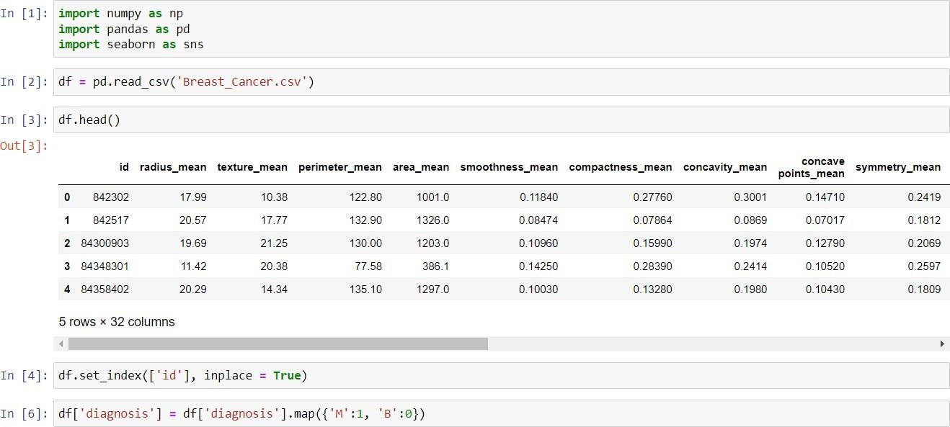

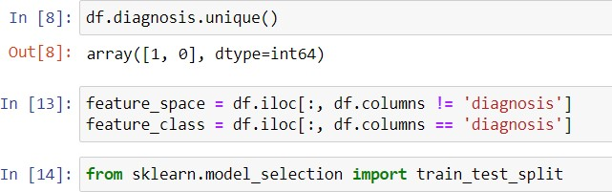

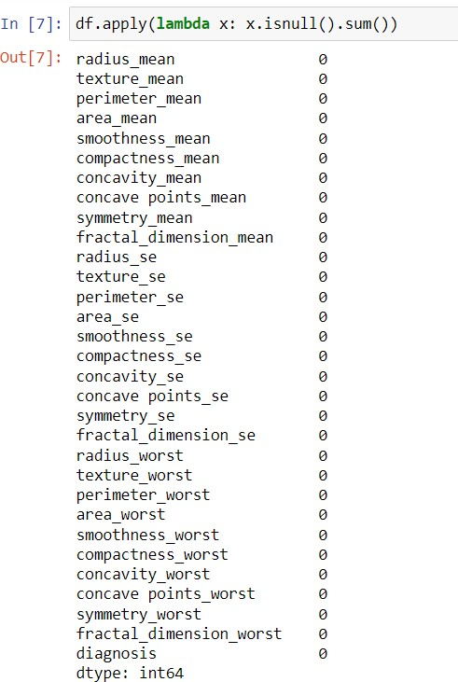

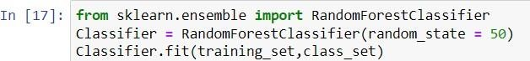

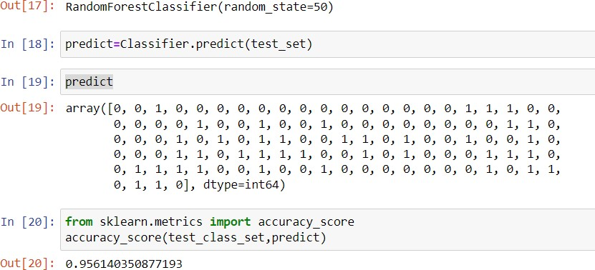

**Result: Accuracy of the model is approximately 95%.**